Computer Network Lab


LAB WORK # 07

Submitted By
QASIM ALI (20P-0070)
Submitted to : Hurmat Hidayat
(INSTRUCTOR CS)

DEPARTMENT OF COMPUTER SCIENCE

FAST NATIONAL UNIVERSITY OF COMPUTER AND EMERGING SCIENCES, PESHAWAR

Session 2020-2024

Task 1: Build the network topology
2. Configure IP addresses on the PCs, DNS Server and the Mail Server
• Mail Server IP address: 192.168.1.2
• PC0 IP address: 192.168.1.4
• PC1 IP address: 192.168.1.3
• DNS server IP address: 192.168.1.5

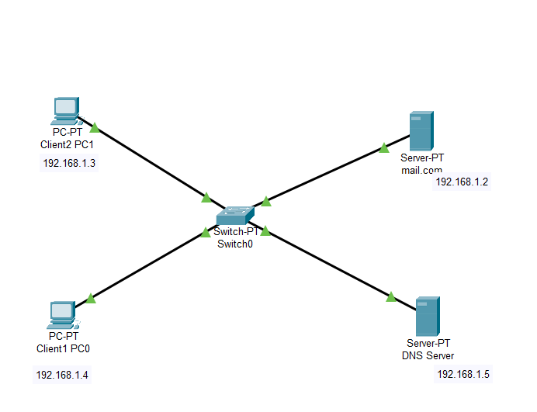

DNS Server :
->configure the email server:
Provide the Domain name of the server then click on Set to set it. In this example I’ve used the name ‘mail.com’ .
Proceed and add users and provide their passwords. I have two email clients(users) with
usernames ‘Client1‘ and ‘Client2‘ with a password ‘Client1‘ and ‘Client2‘
After entering a username and password, click on Add(+) to add the user to the server. You can
optionally remove a user by clicking on Remove (-). You can change a user’s password by clicking
on change password.

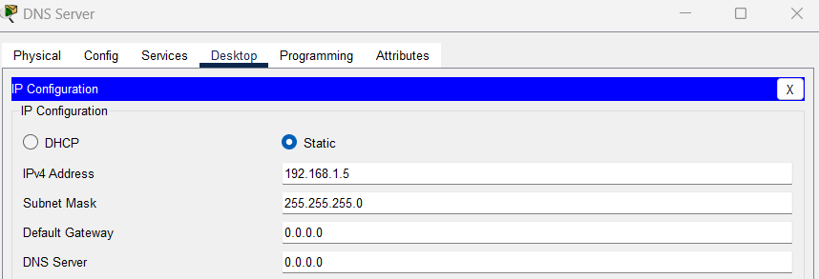

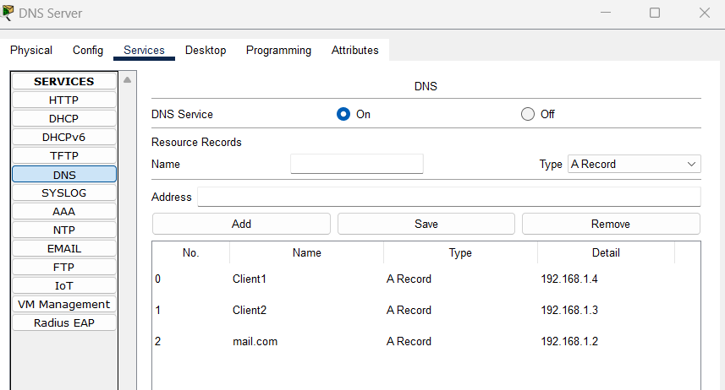

Mail server:

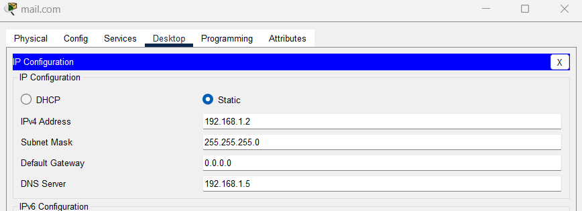

PC 0 : Configure mail clients on the PCs and mail service on the generic server.
Mail Clients:

Click on PC0. Go to its Desktop tab, and click on Email. Configure the email client by filling in the user, server and login information.

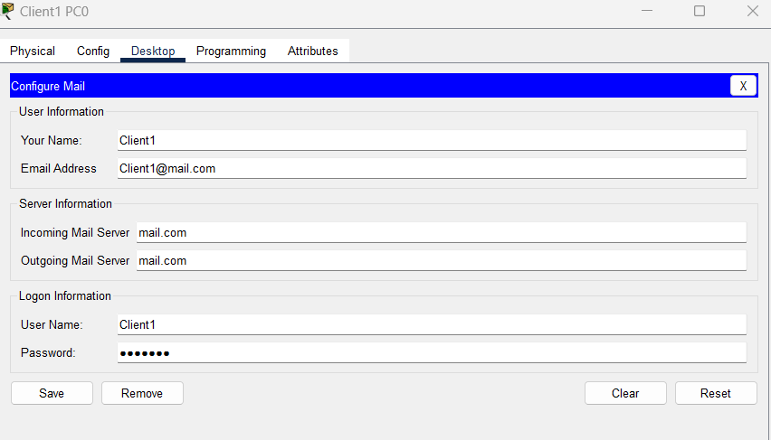

Mail sent and reply :

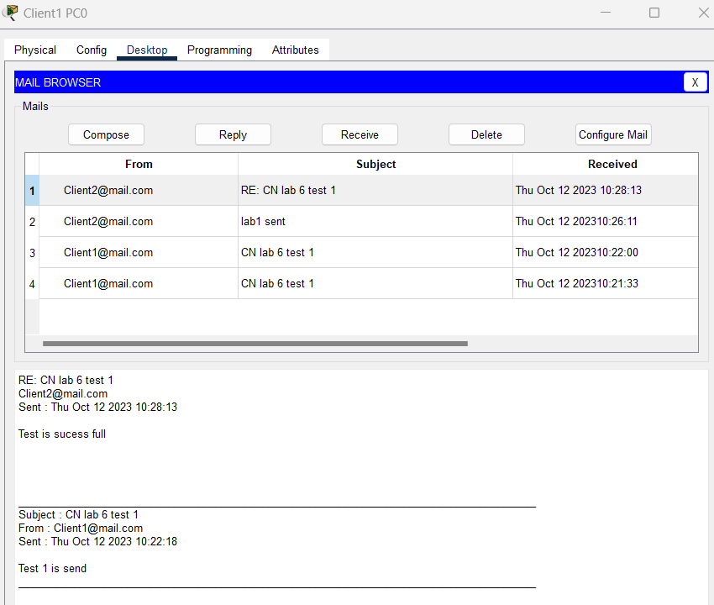

PC 1:
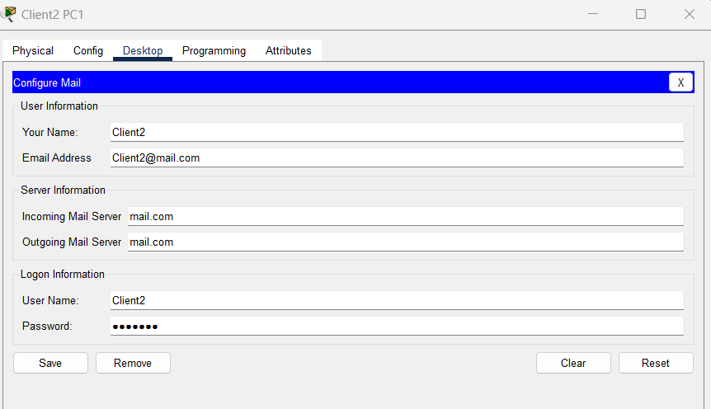

Try to see whether the email from PC0 is received on PC1. On the email client of PC1, click on Receive.
If everything is well set up, the email from PC0 will be received on PC1.

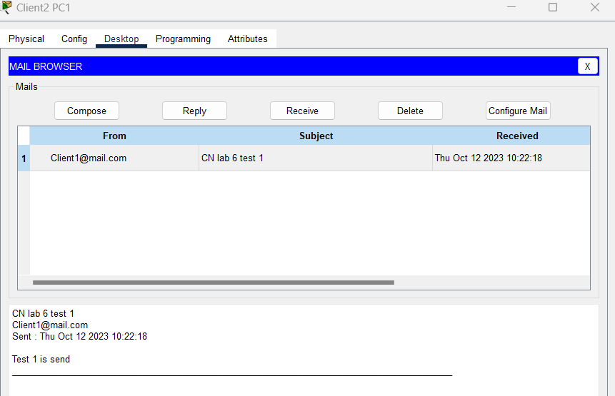

Reply test :

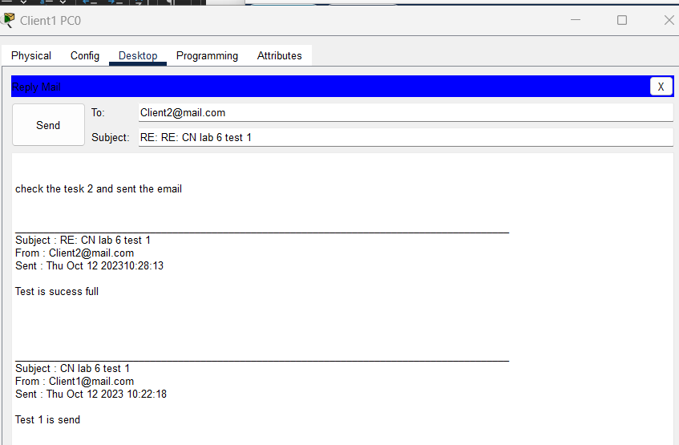

The test 2 is success full work :

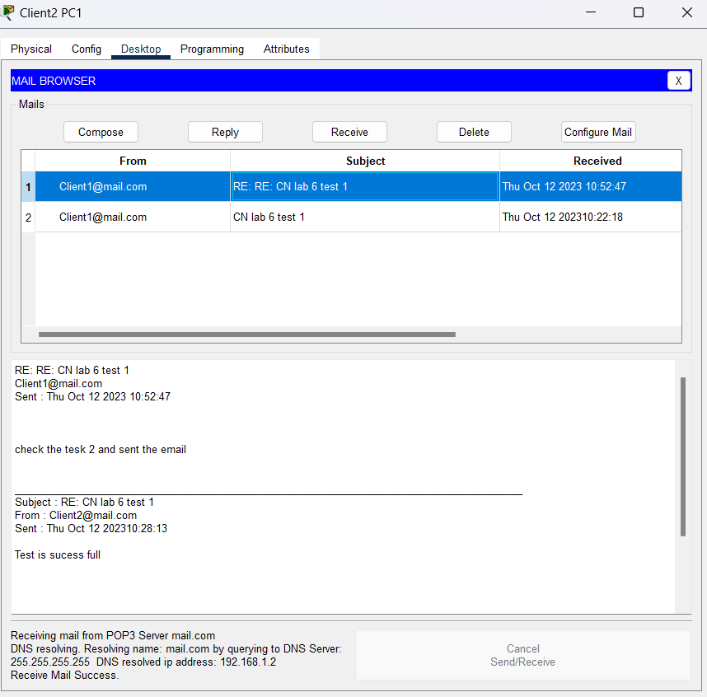

TASk 2 :
Build the network topology

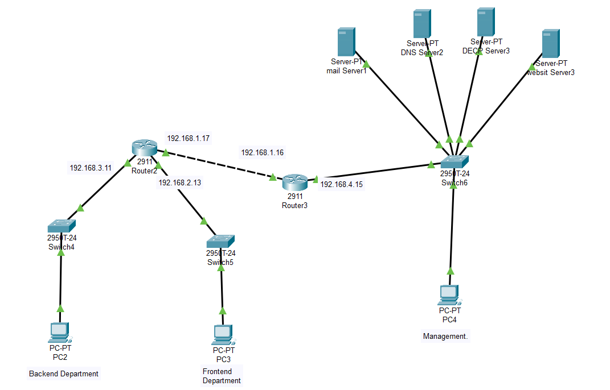

Router ip :

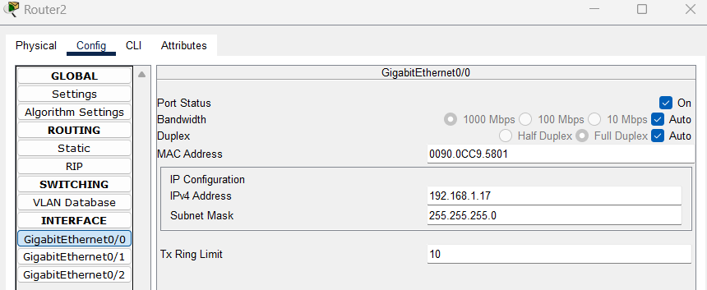

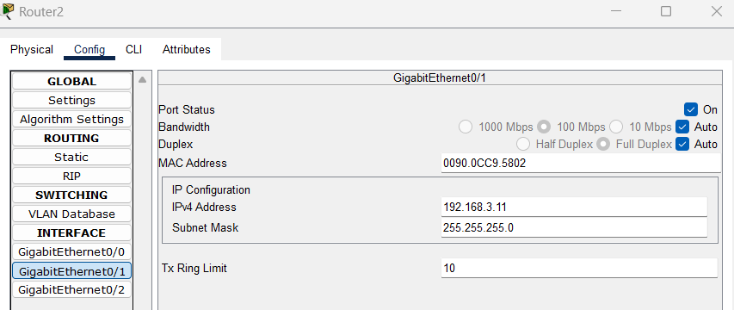

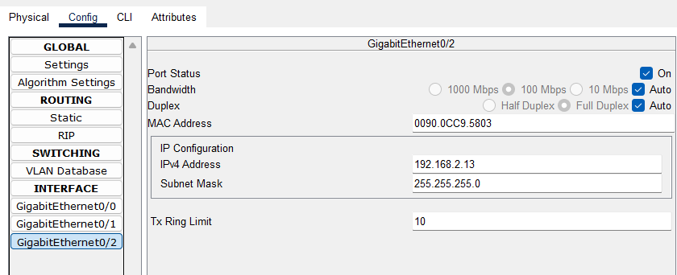

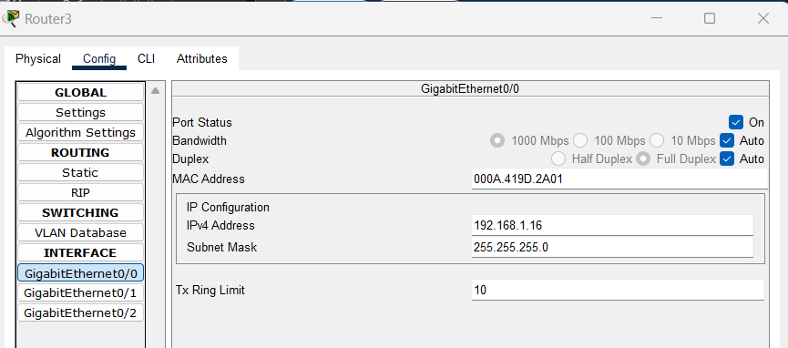

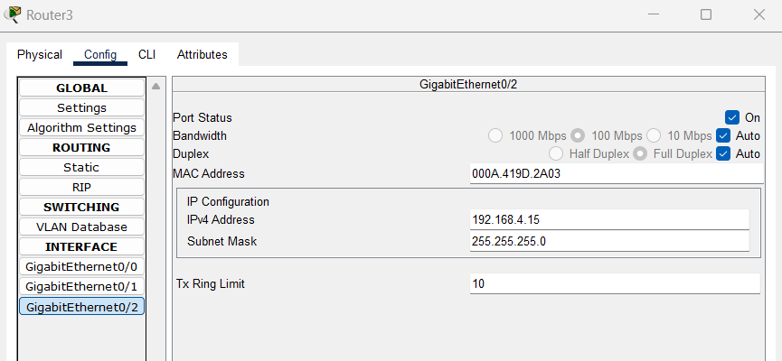

Static:
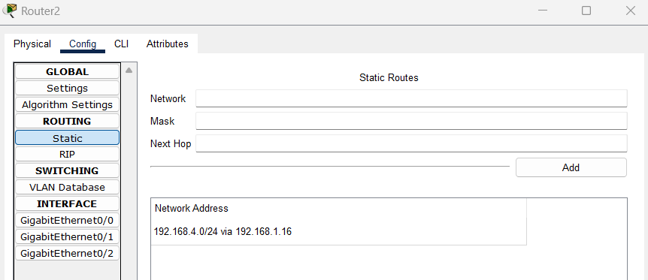

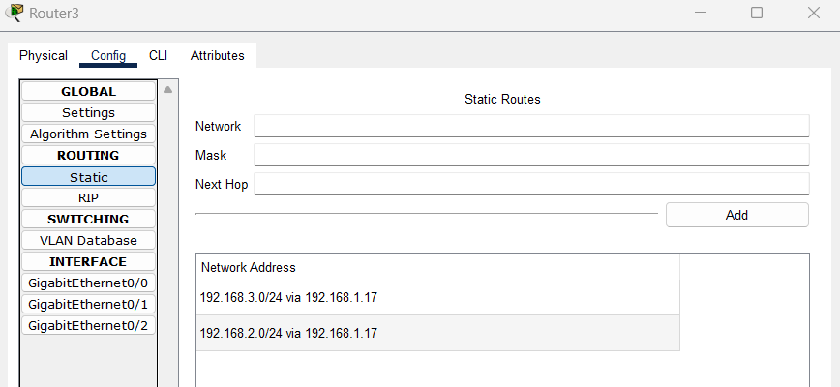

Mail server:

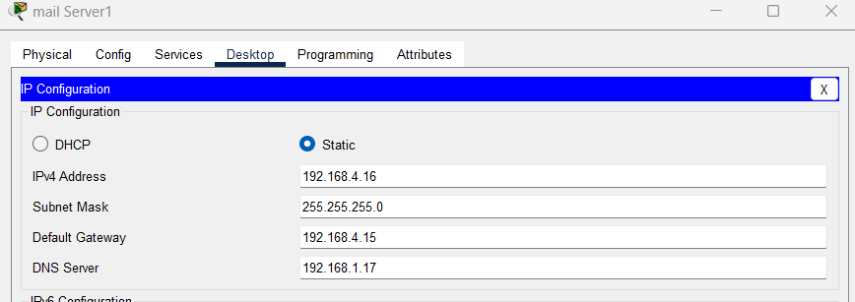

DNS Server :
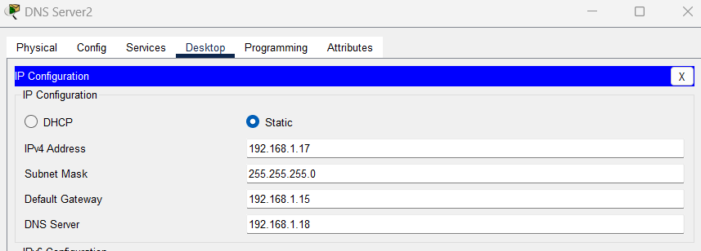

DECP Server:
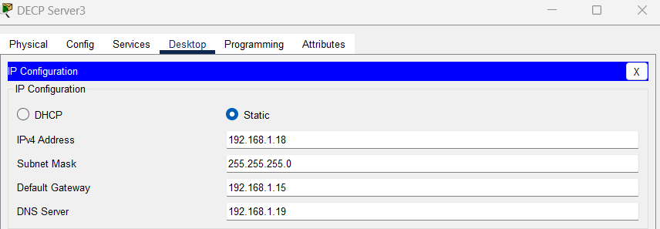

Website Server:
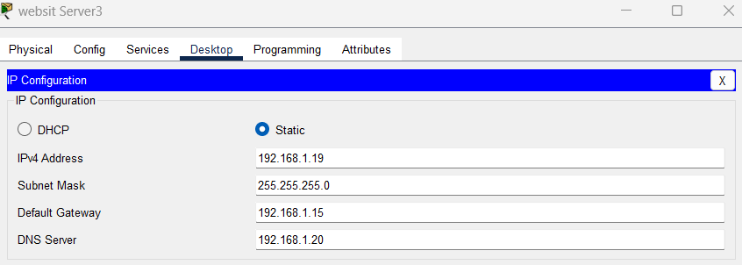

Email services on :
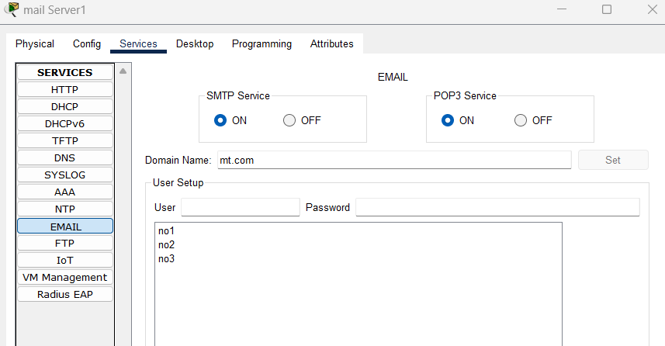

DECP Server :

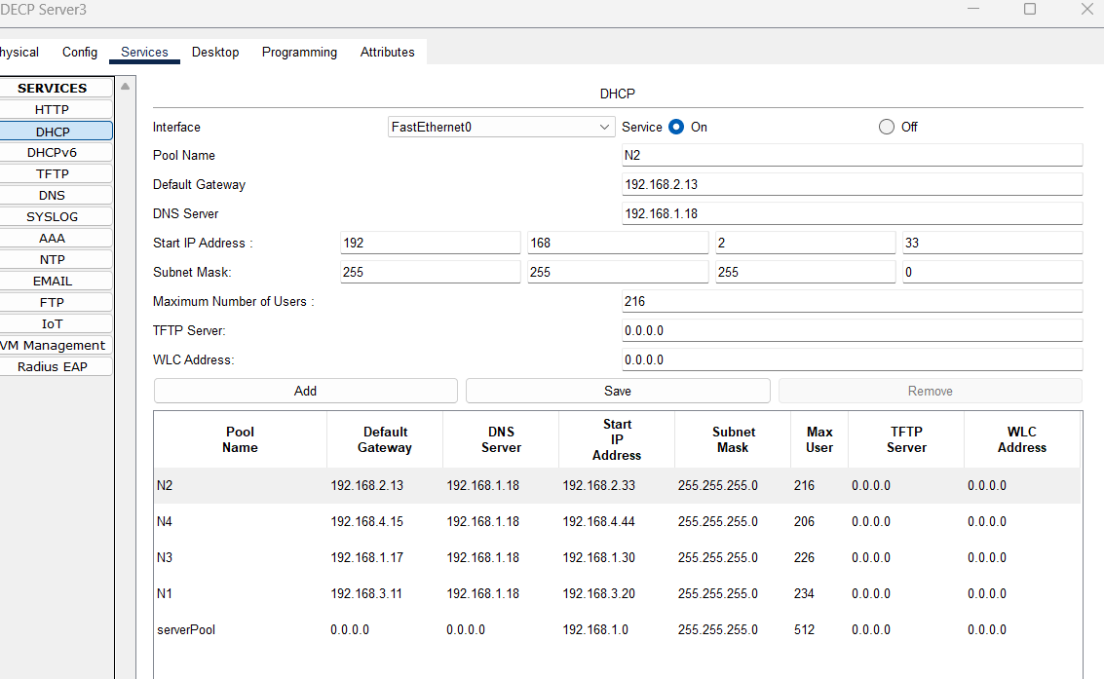

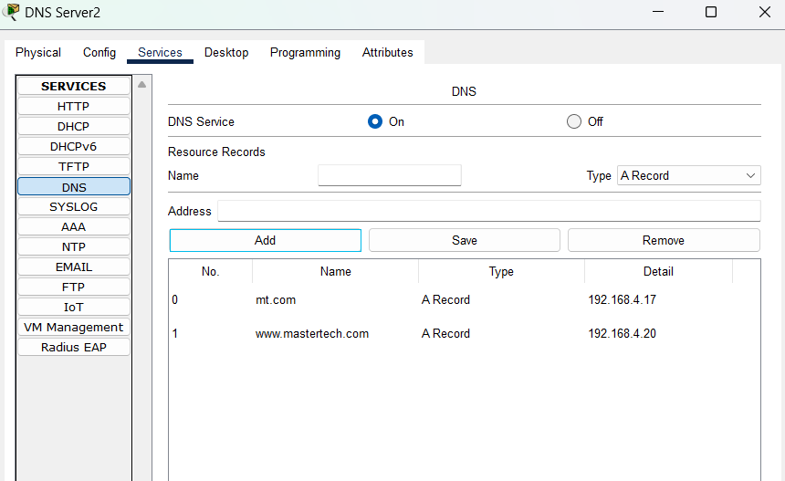

PC confg:

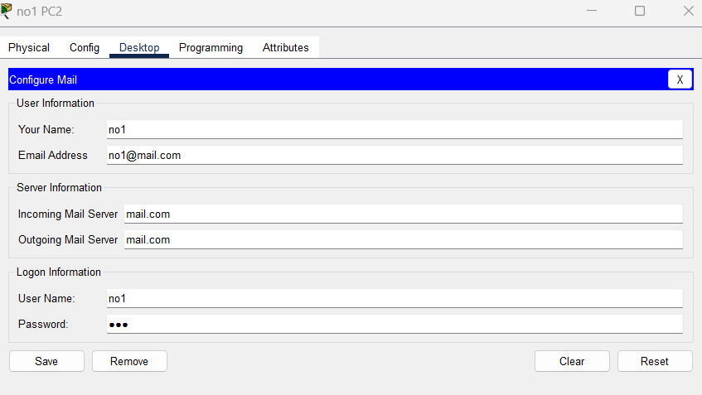

Router CLI :

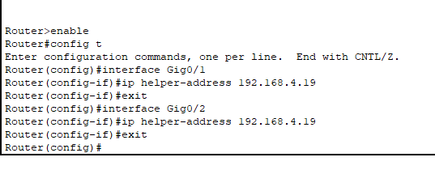

Pc confg:
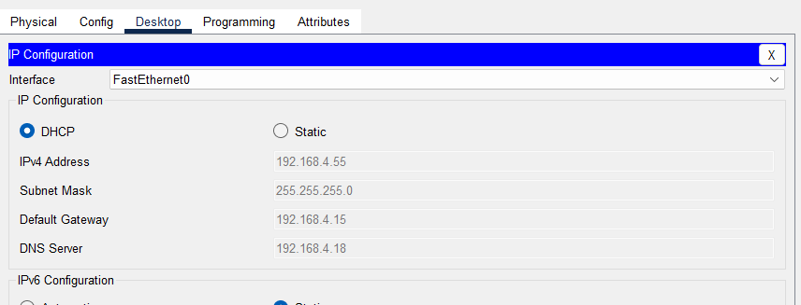

We are add more screen short but time is out running .

